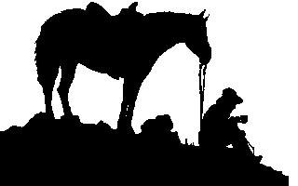 2013 Dodge County Fair - Scheduled Horse Training Demonstrations
Uncommon Horse Sense
Dave Kluge W8416 County Road W, Beaver Dam, WI 53916 - 920-210-0879

Day | 9:00 | 10:00 | 11:00 | 12:00 | 1:00 | 2:00 | 3:00 | 4:00 | 5:00 | 6:00 | 7:00
Wednesday  August 14 |  | Leadership  From The  Ground Up |  | Driving  Harness  Selection  And Fit |  | Safety  The One  Rein Stop |  | Directional  Control  From The  Seat | Upward &  Downward  Transitions
Thursday  August 15 |  | Racetrack To Road  (introducing the race horse  to civilian life) |  |  | Directional  Control  From The  Seat |  | Upward &  Downward  Transitions |  | Teaching  Lateral  Movement | Trail  Obstacles  The Slicker
Friday  August 16 | Leadership  From The  Ground Up |  | Backing  With  Lightness |  | Trail  Obstacles  The  Bridge |  | Teaching  Lateral  Movement |  | Getting  Ready For  Roping | Trail  Obstacles  Poles
Saturday  August 17 |  |  | Horse Starting  Demonstration  Part I |  | Getting  Ready For  Roping |  | Introduction To Driving  Singles & Pairs/Teams |  |  | Lateral Movement  the key to  performance
Sunday  August 18 |  |  | Horse Starting  Demonstration  Part II |  | Trail  Obstacles  The Gate |  | Horse Starting  The Horse’s First  Rides
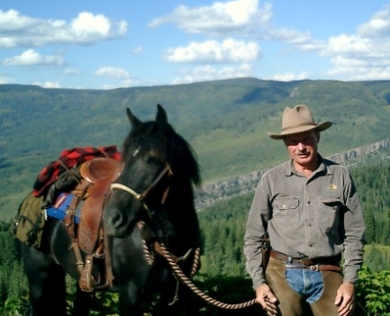
Dave Kluge - Born and raised on a farm in Wisconsin, Dave has been riding, driving and/or training horses since he was eight. After graduating from the University of Wisconsin-Stout with a bachelors' degree in education, he taught high school in Illinois before moving to Colorado. His study of natural horsemanship began after attending a clinic conducted by Tom Dorrance. That started him on an intense course of study, attending numerous clinics by such noted clinicians as: Ray Hunt, Buck Brannaman, Pat Parelli, Tom Dorrance, John Lyons, Craig Cameron, Richard Shrake, Curt Pate and Lee Cooper-Smith to name just a few.
Dave has been conducting Natural Horsemanship clinics throughout the United States and abroad since 1994. During this time he has personally started well over 600 horses many of which had been rejected by other trainers as "un-trainable" (not one of those horses bucked when ridden the first time). He has conducted clinics on a variety of subjects including: Horse Starting, Trailer Loading, Leadership from the Ground Up, Foundational Riding Skills, Intermediate Riding Skills, Basic Ranch Roping, Fundamentals of Team Penning, Preparing the Horse for Driving, Working Cattle Skills and Leadership for the Horse.

